Issue 1: Campaign Allowed to be Scheduled for a Past Date or Time
Description:
The application incorrectly permits the selection and scheduling of email campaigns using historical dates and times. When a user inputs a past date/time into the schedule picker and commits the action, the system processes it as a valid entry and triggers a success status instead of enforcing future-date validation.
Steps to Reproduce:
- Click on the New Campaign button and populate the required fields.
- Click the Save Draft button to save the progress.
- Click the Schedule tab on the Campaign Dashboard.
- Click the Campaign Draft dropdown field and select the recently created campaign draft.
- Click on the Schedule Date and Time field to open the calendar/time picker.
- Select or manually enter a date or time that occurs in the past (relative to the current system date and time).
- Click the Schedule button.
Expected Result:
The system should restrict campaign scheduling to future dates and times only. Past dates and times should be disabled (greyed out) within the date-time picker interface, or clicking the "Schedule" button with a past timestamp should trigger a clear validation error message (e.g., "Please select a future date and time"), blocking submission.
Actual Result:
The submission goes through successfully, and a "Campaign scheduled successfully" confirmation response is received by the client interface.

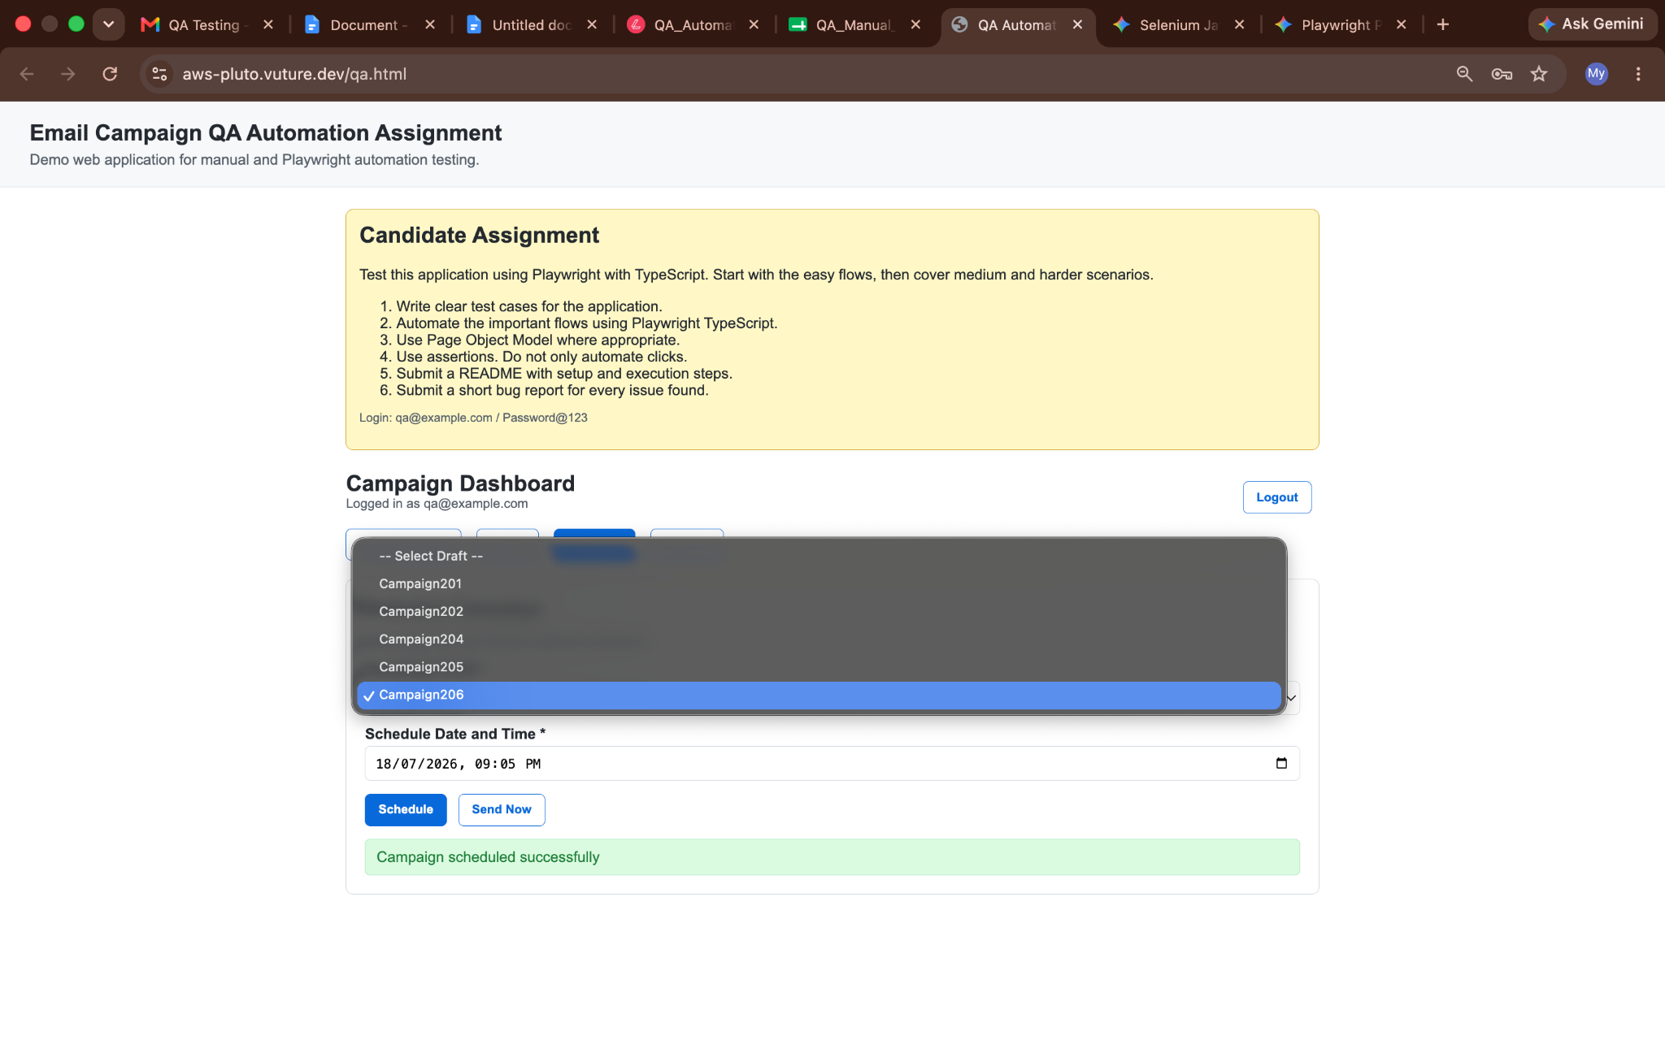
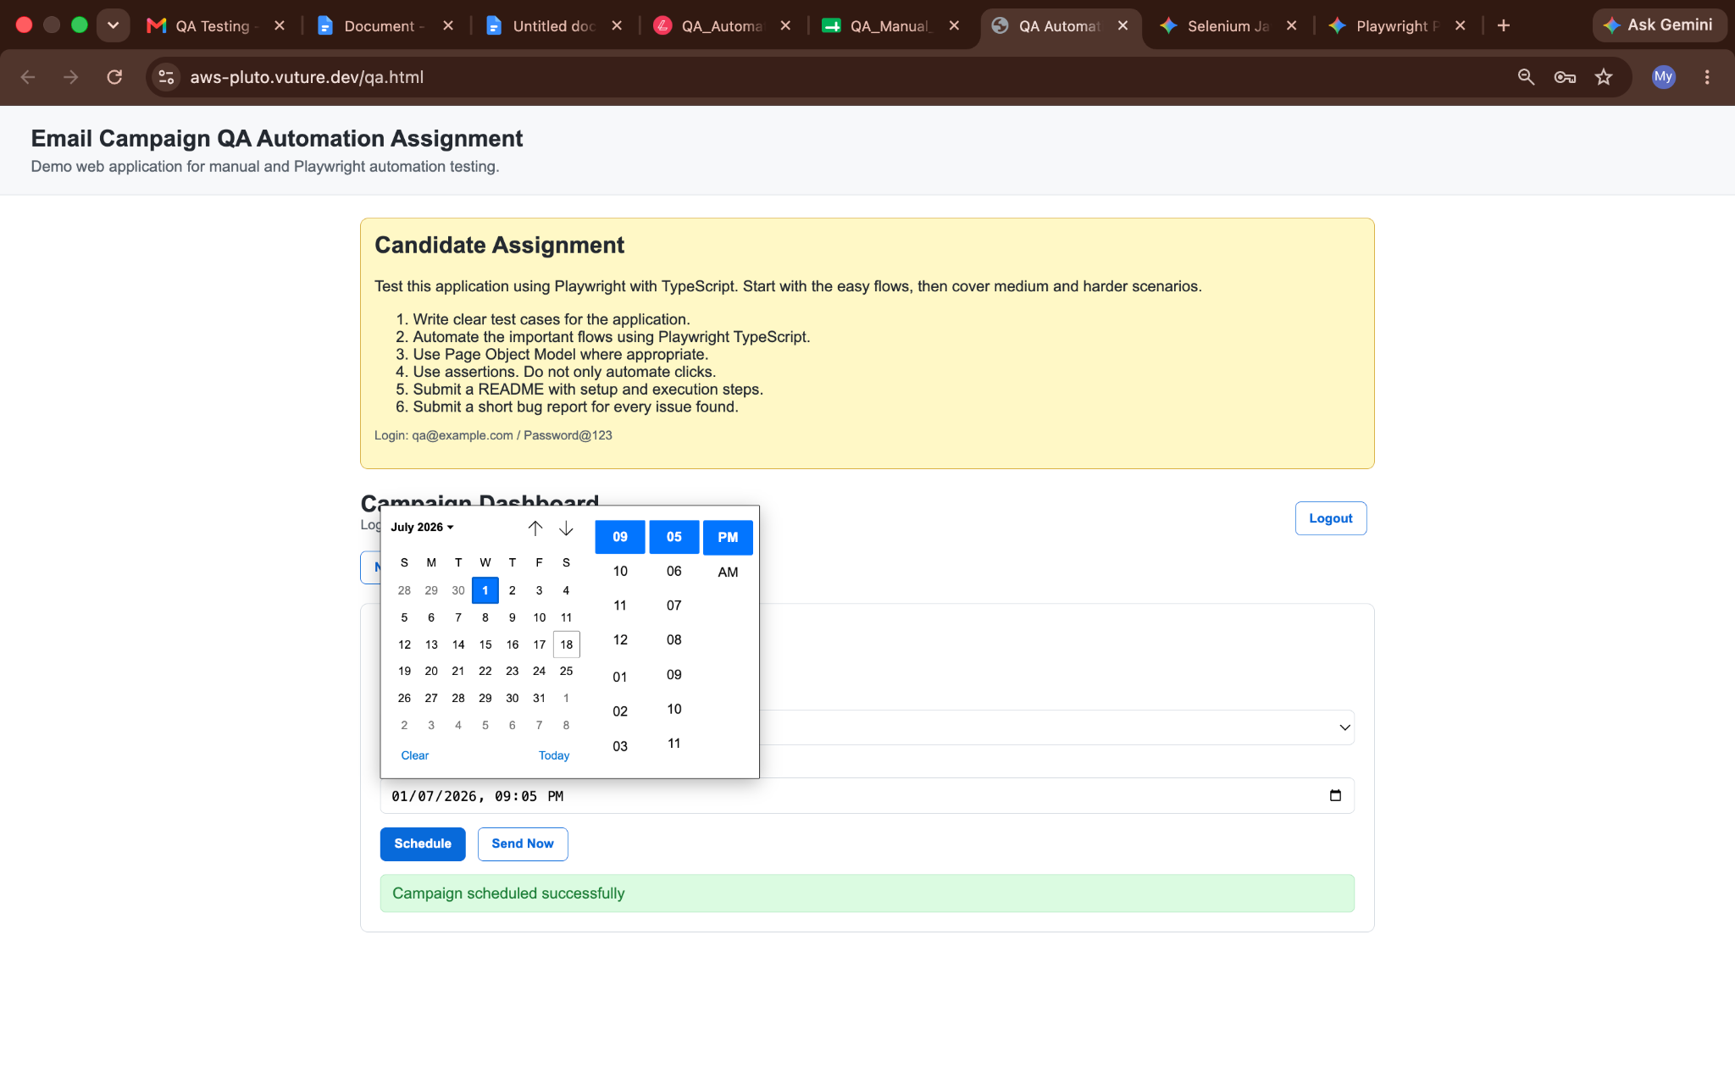
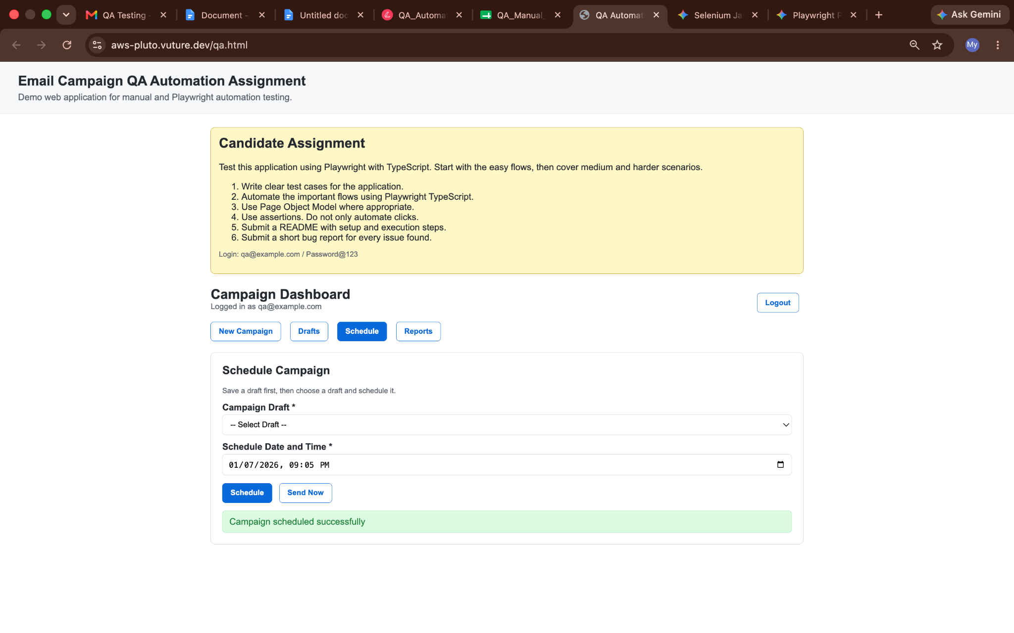
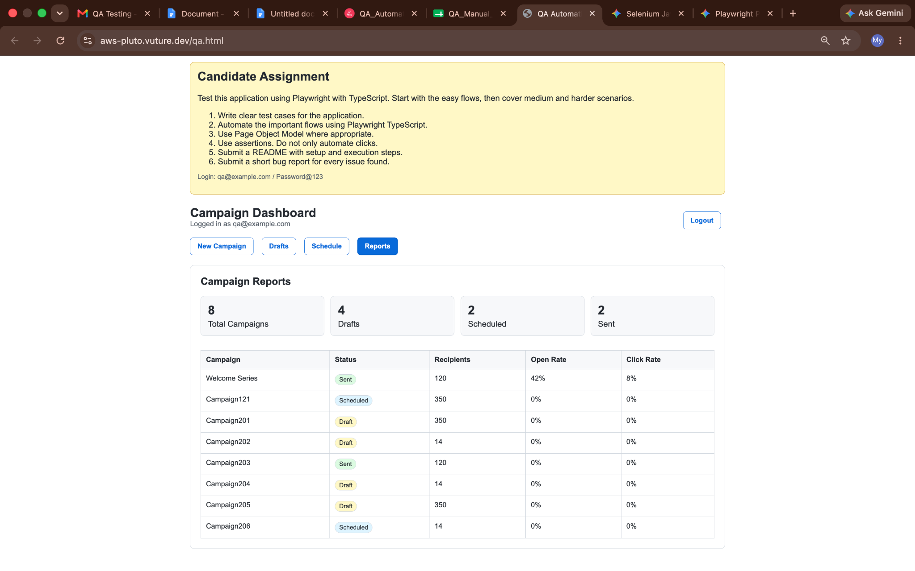

Issue 2: Campaign Draft Dropdown Options Menu Misalignment
Description:
There is a UI positioning defect on the Schedule Campaign page where the options container for the "Campaign Draft" dropdown is completely misaligned. Instead of rendering directly beneath the dropdown field element, the expanded options menu is shifted significantly to the left, overflowing the form layout boundaries.
Steps to Reproduce:
- Navigate to the Schedule tab on the Campaign Dashboard.
- Observe the initial state of the Campaign Draft dropdown field.
- Click on the Campaign Draft dropdown field to expand the list of available campaign options.
Expected Result:
The dropdown options container should align symmetrically with the parent input field, matching its horizontal start point and width directly underneath the input element.
Actual Result:
The expanded dropdown options menu is shifted heavily to the left, failing to snap to the boundaries of the "Campaign Draft" field wrapper.
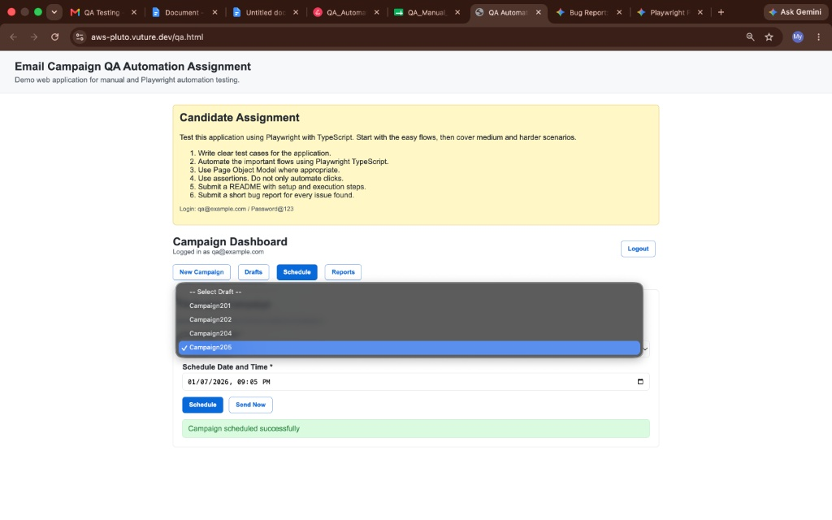

Issue 3: Campaign Subject Not Saved in Drafts, Leading to Preview Error
Description:
When saving a campaign draft, the "Subject" field data is not preserved or recorded by the system. Consequently, the "Subject" column remains blank on the Drafts dashboard. Furthermore, if a user reopens this saved draft and clicks the "Preview" button, a validation error occurs because the missing subject data violates the application's preview requirements.
Steps to Reproduce:
- Click the New Campaign button.
- Populate all required fields, ensuring the Subject field is filled out (e.g., "Campaign204").
- Click the Save Draft button.
- Click the Drafts tab on the Campaign Dashboard.
- Observe the Subject column for the newly saved campaign draft (It is empty).
- Click the Open action button next to the saved campaign draft.
- Note that the Subject field in the form is now completely blank.
- Click the Preview button without re-entering the subject.
Expected Result:
- The text entered in the "Subject" field during creation should be saved successfully with the draft and accurately displayed under the "Subject" column on the Drafts tab.
- Reopening the draft should show the populated subject text, allowing the user to click "Preview" without encountering a validation error.
Actual Result:
- The "Subject" column on the Saved Drafts dashboard remains entirely blank.
- Reopening the draft confirms the Subject text is lost, and clicking the "Preview" button triggers a red validation banner stating: "Subject, sender email and content are required for preview".
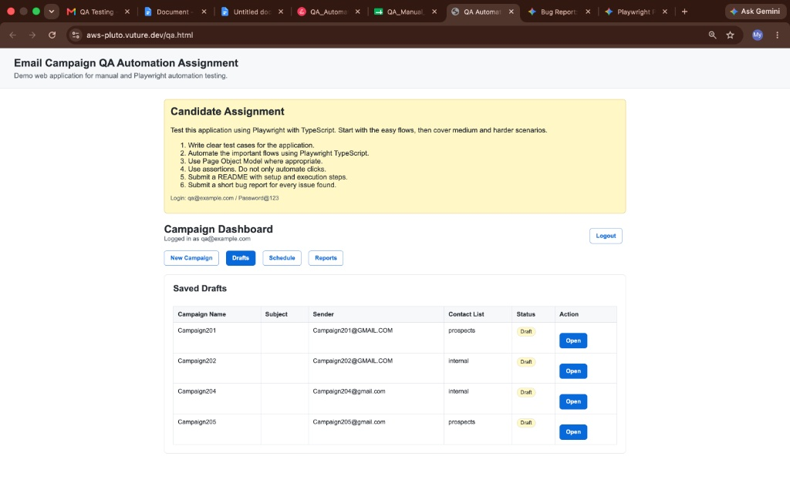
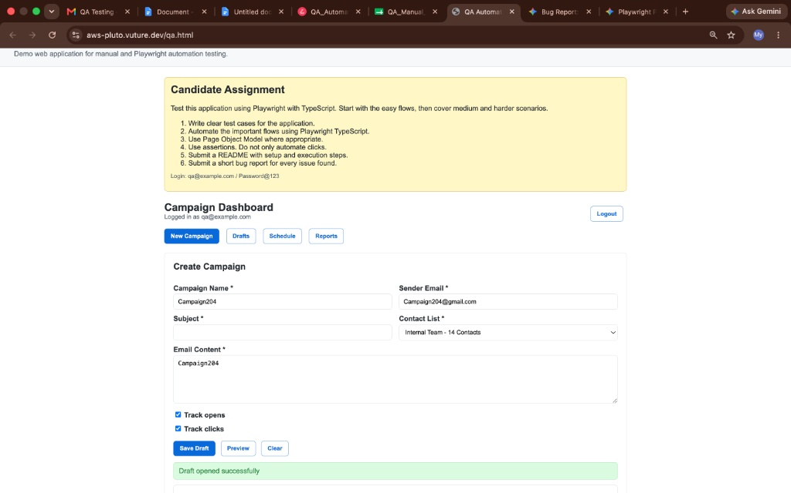
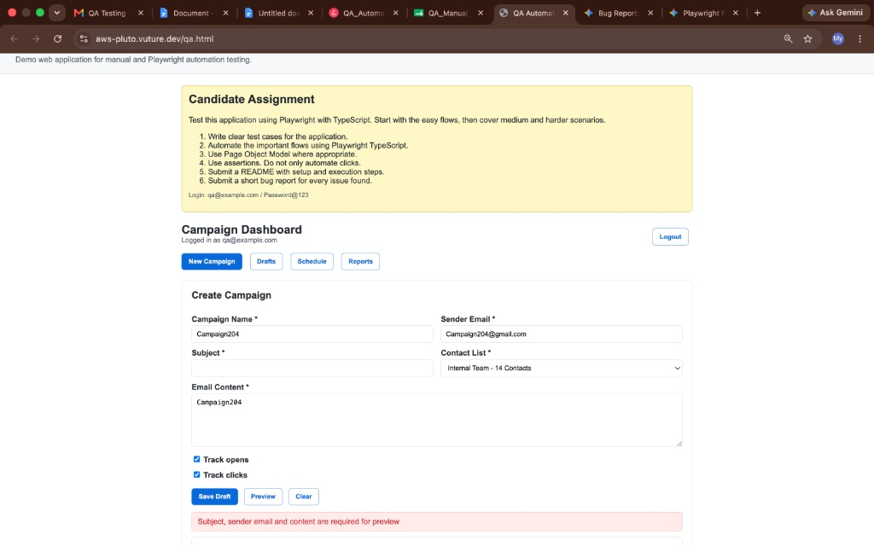

Issue 4: Stale Campaign Preview Retained When Opening a Different Draft
Description:
When a user generates a preview for a campaign draft and subsequently goes back to open a completely different draft, the preview section at the bottom of the page is not cleared or reset. It continues to display the content of the previously viewed campaign, causing severe user confusion regarding which data is active.
Steps to Reproduce:
- Navigate to the Drafts tab on the Campaign Dashboard.
- Open a saved campaign draft (e.g., "Campaign202") and click the Preview button to generate its preview section at the bottom.
- Return to the Drafts tab.
- Click the Open action button for a different campaign draft (e.g., "Campaign205").
- Observe the state of the form fields versus the preview pane at the bottom of the screen.
Expected Result:
Opening a new campaign draft should reset the entire view model state. The preview pane from any previous session should be completely hidden or cleared until the user explicitly clicks the "Preview" button for the currently active campaign.
Actual Result:
The form fields correctly update to show the newly opened campaign details (Campaign205), but the active preview canvas section still lingeringly displays the old campaign text data (Campaign202).
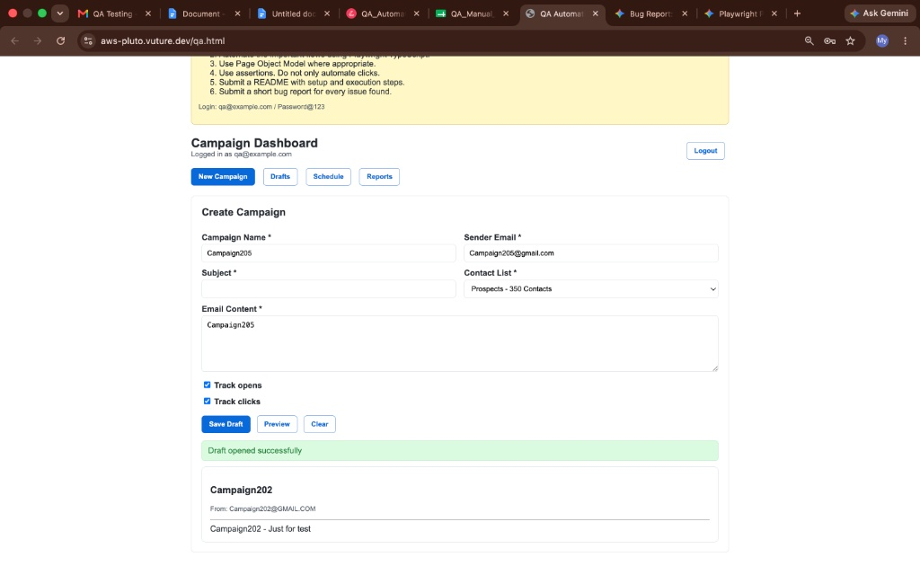

Issue 5: App State Lost on Browser Refresh / Auto-Redirect to Empty Login Page
Description:
The application fails to maintain session state or route persistence during a browser reload. If a user performs any action—such as creating a campaign, checking a report, or scheduling a campaign—and hits the browser's refresh button, the system clears the active session and immediately redirects the user back to the login page with empty credential fields.
Steps to Reproduce:
- Log into the application and navigate to any functional tab (e.g., click the New Campaign, Schedule, or Reports button).
- Perform an action within that view or leave the active tab open.
- Click the browser's Refresh/Reload icon (or press F5 / Cmd + R).
- Observe the page redirection behavior and the application's login state.
Expected Result:
The active user session should persist across page reloads (e.g., using local storage, session storage, or cookies). The application should ideally preserve the current route context and keep the user on the same sub-page or dashboard view without forcing a manual re-login.
Actual Result:
The application reloads directly into the landing page, clearing all state and prompting the user with an empty login form (Login: qa@example.com / Password@123).

Issue 6: UI Alignment Issues in Saved Drafts Table Columns and Action Buttons
Description:
There are multiple visual alignment defects within the "Saved Drafts" grid layout. The text values inside the table cells (such as Campaign Name, Sender, and Contact List) are noticeably top-aligned rather than vertically centered. Additionally, the Open buttons under the "Action" column are completely unaligned with the rest of the text elements, pushed too far down relative to the content row line, breaking standard UI grid consistency.
Steps to Reproduce:
- Navigate to the Drafts tab on the Campaign Dashboard.
- Review the alignment of the text items within the grid columns (Campaign Name, Subject, Sender, Contact List).
- Observe the vertical positioning of the Open button in the Action column for each row.
Expected Result:
All table content, status badges, and action items should share uniform vertical alignment (ideally centered vertically) across the same row. The Open buttons should line up clean and level with the plain text entries.
Actual Result:
The textual data elements stick awkwardly to the top edge of their bounding grid spaces, while the Open call-to-action buttons drop entirely out of line near the bottom boundary of the row cells.
